
Company
Logotype

Cone Beam Computed Tomography- Report



Porur Dental X-rays & CBCT

Patient Name : Mrs. Parimala | Date of Report : 15.10.2025
Age/ Gender : 53 years/ Female | Region of Interest : CBCT Full Skull
Referring doctor: Dr. Selvaganesh | Indication : Implant assessment
Clinical Notes: Nil
PATIENT INFORMATION

CBCT- Full Skull provided
CBCT – IMAGE DETAILS

RADIOGRAPHIC INTERPRETATION

- Complete loss of crown and root structure in relation to 18, 26, 28, 36, 38, 46, 47, 48.
- The alveolar ridge in relation to the maxillary and mandibular alveolar ridge is present with normal trabecular pattern.
- Increased interdental spacing present in the lower anterior region.
- Hyperdense restorative material within the root canals, extending upto the apical third of the roots and hyperdense crown structure present in relation to 16.
- Mucosal thickening evident in relation to the left maxillary sinus.

IMPLANT ASSESSMENT

 | 26 region
Sub-Crestal (in mm) | 5.7
Mid- Crestal (in mm) | 6.4
Distance between the alveolar ridge and floor of the maxillary sinus (in mm) | 2.8

 | 36 region | 46 region | 47 region
Sub-Crestal (in mm) | 4.8 | 5.4 | 4.9
Mid- Crestal (in mm) | 7.3 | 8.2 | 7
Distance between alveolar ridge and the inferior alveolar nerve canal (in mm) | 11.7 | 11.4 | 11.5
Distance between alveolar ridge and the inferior border of mandible (in mm) | 22.6 | 21.5 | 21.3

RADIOGRAPHIC IMPRESSION

- Partially edentulous maxillary and mandibular arch.
- Root canal treated with crown in relation to 16.
- Left maxillary sinusitis.

Kindly correlate with clinical findings


IMAGES FOR REFERENCE

RECONSTRUCTED PANORAMIC VIEW

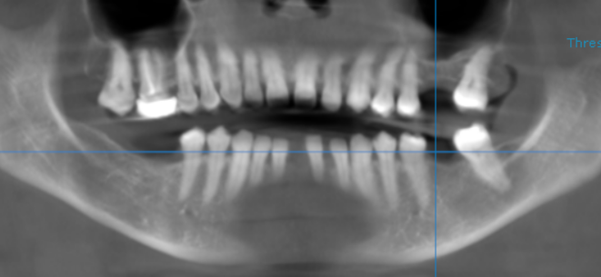

3-DIMENSIONAL VIEW

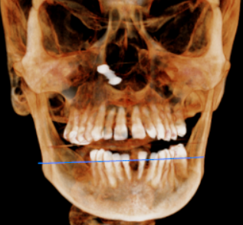

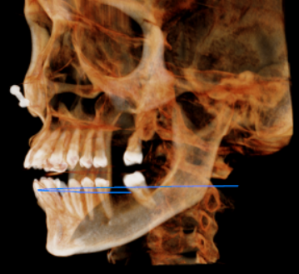
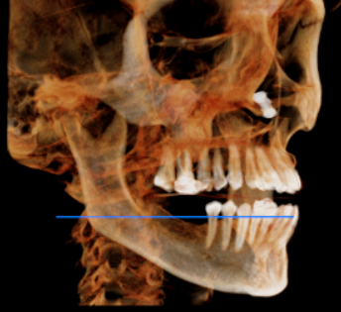

CROSS SECTIONAL VIEW

26 region | 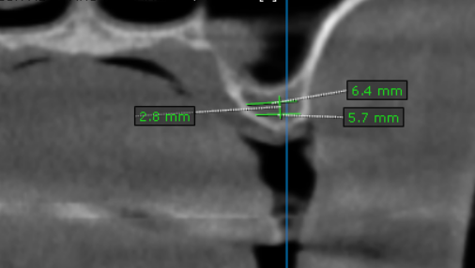
36 region | 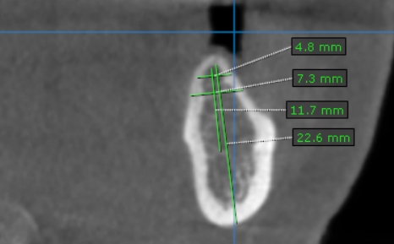
46 region | 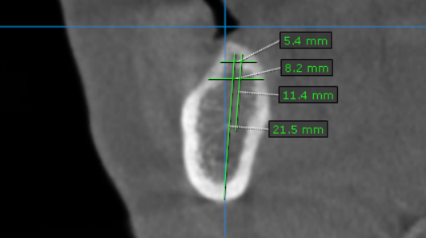
47 region | 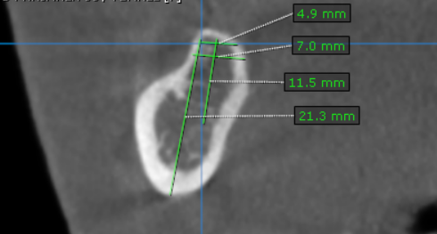

**** End of report ****

